  





**Eco-Friendly Habit Tracker**



|  |  |
| --- | --- |
|  |  |
|  |  |
|  |  |
|  |  |

**Deliverable number:2**

**Date of submission: 17-03-2025**



**Eco-Friendly Habit Tracker**

**Introduction**

In today's fast-paced world, maintaining positive habits while balancing work, health, and personal growth can be challenging. The **Eco-Friendly Habit Tracker** is designed to help users effectively manage their daily routines by providing a structured and intuitive tracking system. To ensure smooth development and implementation, the project follows an organized **To-Do List**, where key tasks are systematically planned before execution. The initial phase of development focuses on essential features such as **user registration, login, habit creation, editing, deletion, and category assignment**. By addressing these fundamental tasks, the project establishes a strong foundation for a seamless and efficient habit-tracking experience, ultimately empowering users to stay consistent and motivated in their journey toward self-improvement.

**User Stories**

1. **Progress Tracking** As a user, I want to see visual charts and logs of my habit performance to track my improvements.
2. **Reminders & Notifications** As a user, I want timely reminders to complete my habits, so I never miss an important task
3. **Detailed Habit History**

As a user, I want to view a detailed history of my habits to analyze past performance.

### User Stories and Specifications

#### 1. Progress Tracking

* **User Story** As a user, I want to see visual charts and logs of my habit performance to track my improvements.
* **Sub-User Stories:**
  + As a user, I want to view pie charts showing my completed and pending habits.
  + As a user, I want to see bar charts that display my habit consistency over time.
  + As a user, I want to quickly analyze which habits I’m improving and which need more effort.

#### 2. Reminders & Notifications

* **User Story:** As a user, I want timely reminders to complete my habits, so I never miss an important task
* **Sub-User Stories:**
  + As a user, I want to set daily or weekly reminders for specific habits.
  + As a user, I want to receive pop-up or system tray notifications at selected times.
  + As a user, I want to customize when and how I receive these reminders

1. **Detailed Habit History**

* **User Story:** As a user, I want to view a detailed history of my habits to analyze past performance.
* **Sub-User Stories:**
* As a user, I want to see which habits I completed on specific days.
* As a user, I want to filter my history by week, month, or category.
* As a user, I want to identify patterns in missed or successful habits to improve planning

**Scrum Boards**

**Snapshot1**

**Snapshot2**

**Snapshot3**

**Workload Division**

| Team directory | | |
| --- | --- | --- |
| **Team Member** | **Role** | **Responsibilities** |
| **Muhammad Daniyal Qureshi** | Lead & Backend Developer | Backend development, database integration, API implementation, and ensuring data security. |
| **Muhammad Ahmad** | Frontend Developer & Architect | UI development, integration of charts and reminders, frontend logic implementation, and interface responsiveness. |
| **Muhammad Sufyan** | Requirement Engineer & Tester | Requirement documentation, functional testing, validation of features, and bug reporting. |

**Iteration 2 implementation screen shots**

**Notifications:**

**History:**

**Progress Tracking:**

**Design:**

1. **Activity Diagram: Page 1:**

**Page 2:**

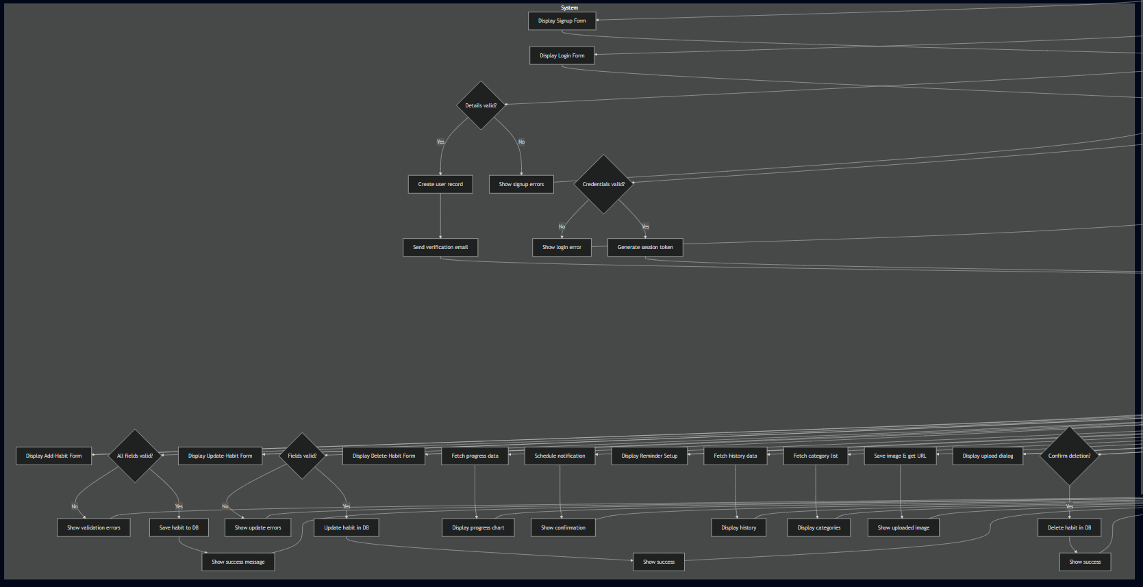

1. **Sequence diagram**

**Page 1:**

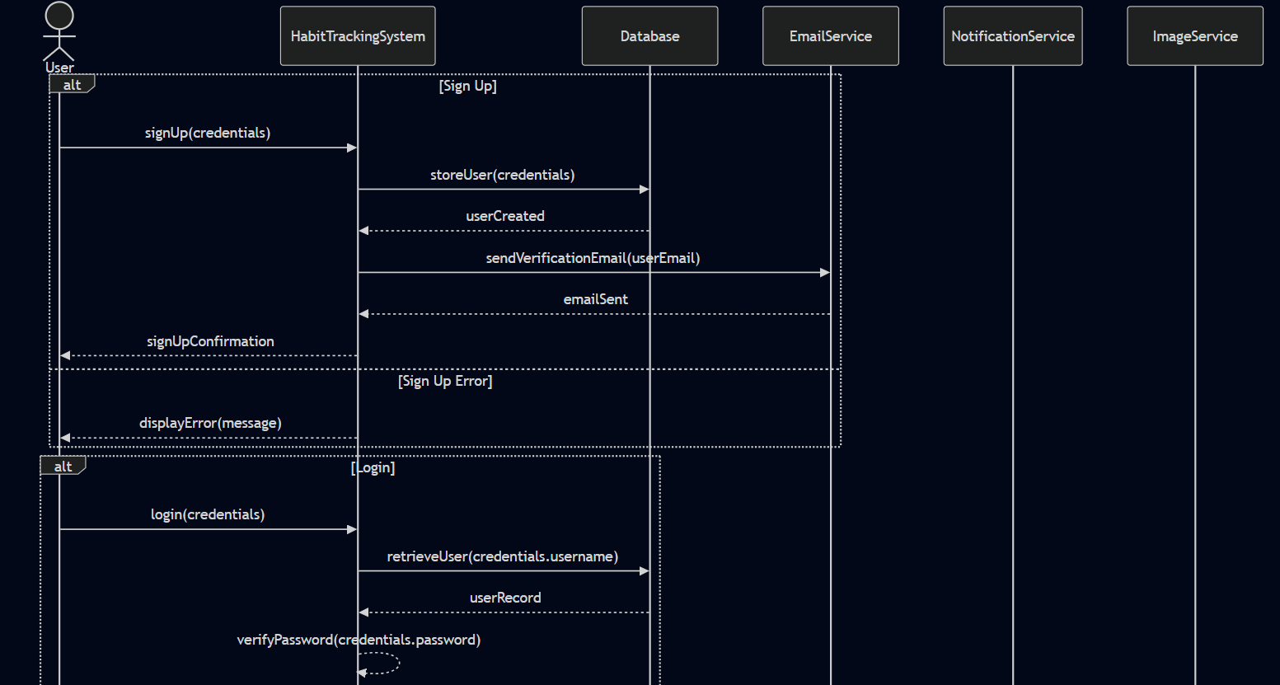

**Page 2:**

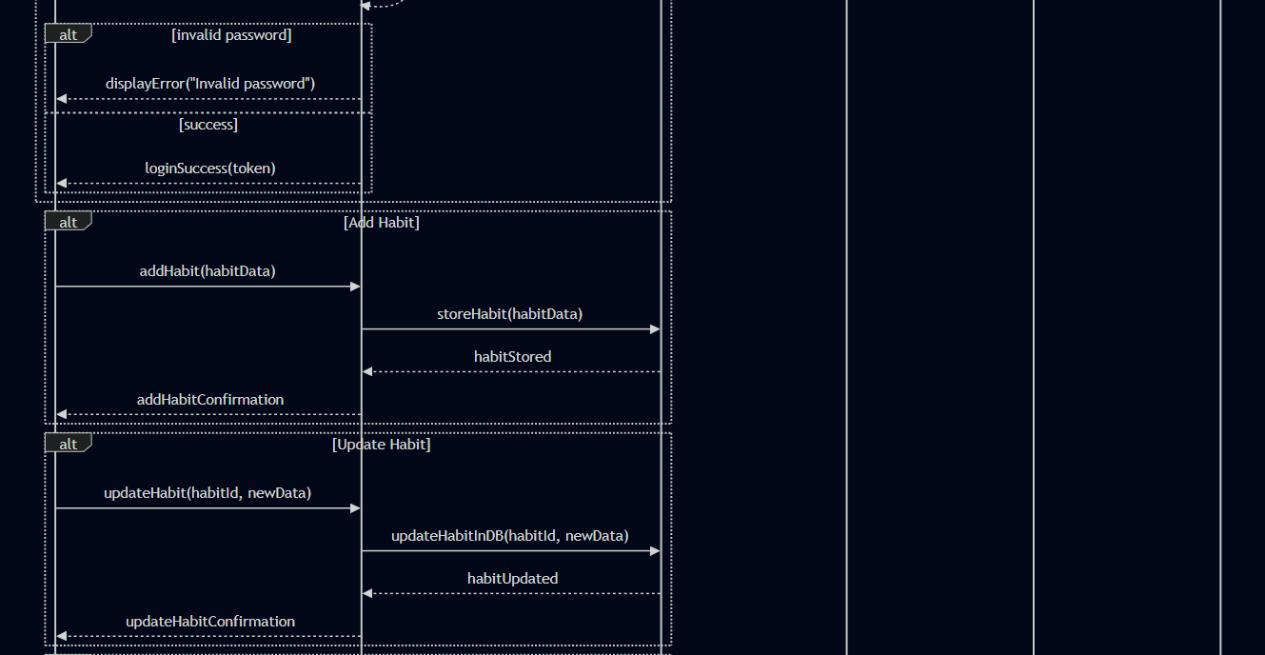

**Page 3:**

**Page 4:**

**Class Diagram:**

**Page1:**

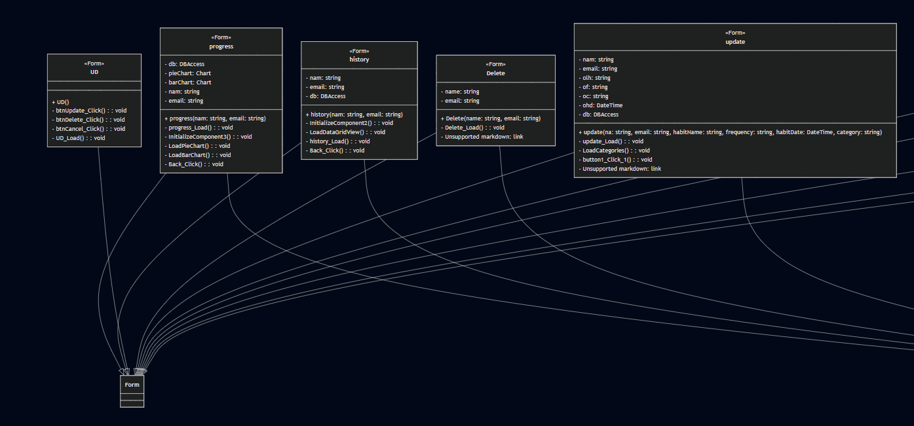

**Page 2:**

**UseCase Diagram:**

